<http://www.circuitbasics.com/how-to-hack-a-headphone-jack/>

standard ¼” phone plug for single push button ^

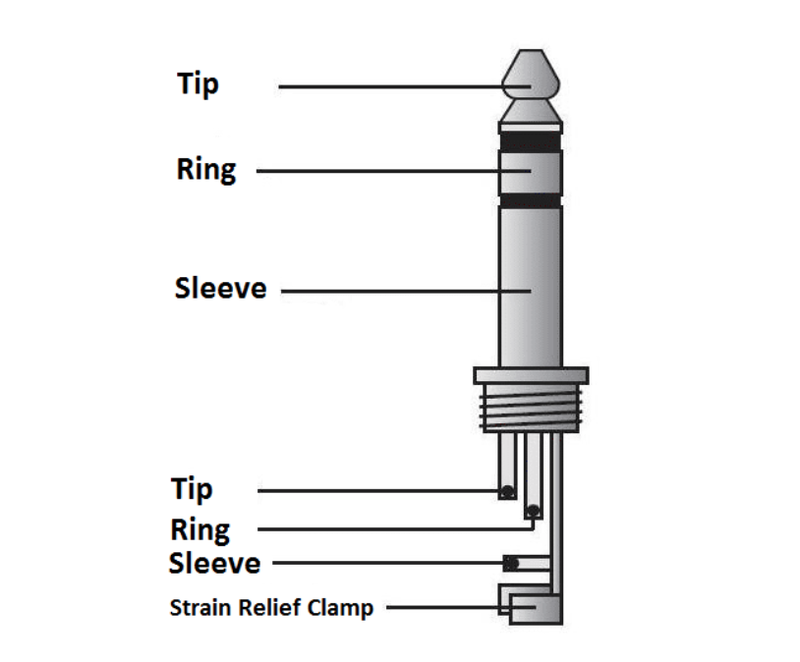

Tip = Power

Ring = Signal

Sleeve = Ground

1/21/19

**Deepthi**: Used oscilloscope to probe both tip and ring with power on the other (5V). Saw signal when pushing the button but the power supply was maxing out a 1.5A. When power was on the ring, power supply was constantly maxed out; when power was on the tip, the power supply dropped down to 0A until the button was pushed (then it maxed out). Does the external circuit need a current limiting resistor….?

**Further Questions:**

Do we need to current limit the incoming signal?

How high and for how long does the voltage signal need to read high to trigger the wall system?

How does the nurse shut off the call?

What is the lag time between pushes for separate calls?